**Prosthetics**

In [medicine](http://en.wikipedia.org/wiki/Medicine), a prosthesis, prosthetic, or prosthetic limb (Greek: *πρόσθεσις* "addition") is an artificial device extension that replaces a missing [body](http://en.wikipedia.org/wiki/Body) part. It is part of the field of [biomechatronics](http://en.wikipedia.org/wiki/Biomechatronics), the science of using mechanical devices with human muscle, skeleton, and nervous systems to assist or enhance motor control lost by trauma, disease, or defect.

**Methods**

Several methods exist that seek to achieve advanced control of motorized neural prosthetics. [Chronic brain implants](http://en.wikipedia.org/wiki/Chronic_Electrode_Implants) record neuronal signals from the [motor cortex](http://en.wikipedia.org/wiki/Motor_cortex), while methods such as [EEG](http://en.wikipedia.org/wiki/EEG) and [fMRI](http://en.wikipedia.org/wiki/FMRI) obtain motor commands non-invasively.[[3]](http://en.wikipedia.org/wiki/Targeted_reinnervation#cite_note-PolikovEtal2005-2)[[4]](http://en.wikipedia.org/wiki/Targeted_reinnervation#cite_note-ShwatzeEtal2006-3) The recorded signals are decoded into electrical signals, and input into assistive devices or motorized prosthetics.[[3]](http://en.wikipedia.org/wiki/Targeted_reinnervation#cite_note-PolikovEtal2005-2) Traditional [myoelectric](http://en.wikipedia.org/wiki/Neural_prosthetics#Motor_prosthetics_for_conscious_control_of_movement) prostheses utilize surface EMG signals from the remains of the amputated limb.[[5]](http://en.wikipedia.org/wiki/Targeted_reinnervation#cite_note-Sears1992-4) For example, a patient may flex a shoulder muscle in order to generate EMG signals that may be used to send “bend elbow” command to the prosthesis. However, there are shortcomings to all of these methods. [Chronic implants](http://en.wikipedia.org/wiki/Chronic_Electrode_Implants) fail over a period of time because neuronal signal degrade due to tissue immune response to foreign bodies.[[3]](http://en.wikipedia.org/wiki/Targeted_reinnervation#cite_note-PolikovEtal2005-2) EEG and fMRI do not obtain as strong signals as direct electrode implant.[[4]](http://en.wikipedia.org/wiki/Targeted_reinnervation#cite_note-ShwatzeEtal2006-3) Traditional myoelectric prostheses are unable to provide multiple control signals simultaneously, thus only one action can be performed at a time.[[5]](http://en.wikipedia.org/wiki/Targeted_reinnervation#cite_note-Sears1992-4) They are also unnatural to use because the users have to use muscles (such as shoulder) that are not normally involved with lower arm functions to control lower arm functions (such as opening and closing hands).[[5]](http://en.wikipedia.org/wiki/Targeted_reinnervation#cite_note-Sears1992-4) The solution to these problems could include a completely different concept of neural interface.

Motor cortex is a term that describes regions of the [cerebral cortex](http://en.wikipedia.org/wiki/Cerebral_cortex) involved in the planning, control, and execution of voluntary [motor](http://en.wikipedia.org/wiki/Motion_(physics)) functions.

**Brain computer interface**

A brain–computer interface (BCI), sometimes called a direct neural interface or a brain–machine interface, is a direct communication pathway between a [brain](http://en.wikipedia.org/wiki/Brain) and an external device. BCIs are often aimed at assisting, augmenting or repairing human cognitive or sensory-motor functions.

The field of BCI research and development has since focused primarily on neuroprosthetics applications that aim at restoring damaged hearing, sight and movement.

Thanks to the remarkable [cortical plasticity](http://en.wikipedia.org/wiki/Neuroplasticity) of the brain, signals from implanted prostheses can, after adaptation, be handled by the brain like natural sensor or effector channels.[[3]](http://en.wikipedia.org/wiki/Brain_computer_interface#cite_note-2) Following years of animal experimentation, the first neuroprosthetic devices implanted in humans appeared in the mid-nineties.

Neuroplasticity (also known as cortical re-mapping) refers to the ability of the human brain to change as a result of one's experience, that the brain is 'plastic' and 'malleable’. The [brain](http://en.wikipedia.org/wiki/Brain) consists of nerve cells (or "neurons") and [glial cells](http://en.wikipedia.org/wiki/Glial_cells) which are interconnected, and learning may happen through change in the strength of the connections, by adding or removing connections, and by the formation of new cells. "Plasticity" relates to learning by adding or removing connections, or adding cells.

**Nueroprosthetics**

Neuroprosthetics (also called neural prosthetics) is a discipline related to [neuroscience](http://en.wikipedia.org/wiki/Neuroscience) and [biomedical engineering](http://en.wikipedia.org/wiki/Biomedical_engineering) concerned with developing neural [prostheses](http://en.wikipedia.org/wiki/Prosthetics) These devices substitute the functions performed by the [ear drum](http://en.wikipedia.org/wiki/Ear_drum) and [Stapes](http://en.wikipedia.org/wiki/Stapes), while simulating the frequency analysis performed in the [cochlea](http://en.wikipedia.org/wiki/Cochlea). A microphone on an external unit gathers the sound and processes it; the processed signal is then transferred to an implanted unit that stimulates the [auditory nerves](http://en.wikipedia.org/w/index.php?title=Auditory_nerves&action=edit&redlink=1) through a [microelectrode array](http://en.wikipedia.org/wiki/Microelectrode_array). Wireless electrical recording from the brain of awake, freely behaving animals can open many important doors into understanding how the brain handles different functions. Accurately probing and recording the electrical signals in the brain would help better understand the relationship among a local population of neurons that are responsible for a specific function

**Nueroprosthetics vs BCI**

Neuroprosthetics is an area of [neuroscience](http://en.wikipedia.org/wiki/Neuroscience) concerned with neural prostheses—using artificial devices to replace the function of impaired nervous systems or sensory organs. The most widely used neuroprosthetic device is the [cochlear implant](http://en.wikipedia.org/wiki/Cochlear_implant), which, as of 2006, has been implanted in approximately 100,000 people worldwide.[[4]](http://en.wikipedia.org/wiki/Brain_computer_interface#cite_note-3) There are also several neuroprosthetic devices that aim to restore vision, including [retinal implants](http://en.wikipedia.org/wiki/Retinal_implant).

The differences between BCIs and neuroprosthetics are mostly in the ways the terms are used: neuroprosthetics typically connect the nervous system to a device, whereas BCIs usually connect the brain (or nervous system) with a computer system. Practical neuroprosthetics can be linked to any part of the nervous system—for example, peripheral nerves—while the term "BCI" usually designates a narrower class of systems which interface with the central nervous system.

<http://en.wikipedia.org/wiki/Brain_computer_interface>

**Multielectrode arrays (MEAs)** or microelectrode arrays are devices that contain multiple plates or shanks through which neural [signals](http://en.wikipedia.org/wiki/Signal_(electronics)) are obtained or delivered, essentially serving as neural interfaces that connect [neurons](http://en.wikipedia.org/wiki/Neuron) to [electronic circuitry](http://en.wikipedia.org/wiki/Electric_circuit). There are two general classes of MEAs: implantable MEAs, used [*in vivo*](http://en.wikipedia.org/wiki/In_vivo), and non-implantable MEAs, used [*in vitro*](http://en.wikipedia.org/wiki/In_vitro).

**Electroencephalography (EEG)** is the recording of [electrical](http://en.wikipedia.org/wiki/Electrical) activity along the scalp produced by the firing of [neurons](http://en.wikipedia.org/wiki/Neurons) within the [brain](http://en.wikipedia.org/wiki/Brain).

**Electrocardiography** (ECG, or EKG [from the [German](http://en.wikipedia.org/wiki/German_language) *Elektrokardiogramm*]) is a transthoracic interpretation of the [electrical](http://en.wikipedia.org/wiki/Electricity) activity of the [heart](http://en.wikipedia.org/wiki/Heart) over [time](http://en.wikipedia.org/wiki/Time) captured and externally recorded by skin electrodes.[[1]](http://en.wikipedia.org/wiki/Electrocardiography#cite_note-LHC-0) It is a [noninvasive](http://en.wikipedia.org/wiki/Non-invasive_(medical)) recording produced by an electrocardiographic device. The ECG works mostly by detecting and amplifying the tiny electrical changes on the skin that are caused when the heart muscle "depolarises" during each heart beat. At rest, each heart muscle cell has a charge across its outer wall, or [cell membrane](http://en.wikipedia.org/wiki/Cell_membrane). Reducing this charge towards zero is called de-polarization, which activates the mechanisms in the cell that cause it to contract

**Electromyography (EMG)** is a technique for evaluating and recording the electrical activity produced by [skeletal muscles](http://en.wikipedia.org/wiki/Skeletal_muscles).[[1]](http://en.wikipedia.org/wiki/Electromyography#cite_note-0) EMG is performed using an [instrument](http://en.wikipedia.org/wiki/Medical_instrument) called an electromyograph, to produce a record called an electromyogram. An electromyograph detects the [electrical potential](http://en.wikipedia.org/wiki/Electrical_potential) generated by muscle [cells](http://en.wikipedia.org/wiki/Cell_(biology))[[2]](http://en.wikipedia.org/wiki/Electromyography#cite_note-1) when these cells are electrically or neurologically activated. The signals can be analyzed to detect medical abnormalities, activation level, recruitment order or to analyze the [biomechanics](http://en.wikipedia.org/wiki/Biomechanics) of human or animal movement.

**Chronic Electrode** Implants are electronic devices implanted into the brain. They may record electrical impulses in the brain or they may stimulate neurons with electrical impulses from an external source.

[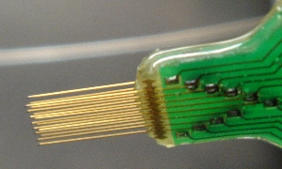](http://upload.wikimedia.org/wikipedia/commons/2/2a/16wire_electrode_array.jpg)

<http://en.wikipedia.org/wiki/Chronic_Electrode_Implants>

Biopotential Electrode Sensors In Ecg/eeg/emg Systems

Electrocardiography (ECG), electromyography (EMG), and electroencephalography (EEG) systems measure heart, muscle, and brain activity (respectively) over time by measuring electric potentials on the surface of living tissue. Nervous stimuli and muscle contractions [CAN](http://www.datasheetdir.com/CAN-Control-Area-Network) be detected by measuring the ionic current flow in the body. This is accomplished using a biopotential electrode. A negatively charged ion is an anion and a positively charged ion is a cation. The current flow in the human body is due to ion flow, not electrons. A biopotential electrode is a transducer that senses ion distribution on the surface of tissue, and converts the ion current to electron current.

Targeted muscle reinnervation(TMR)

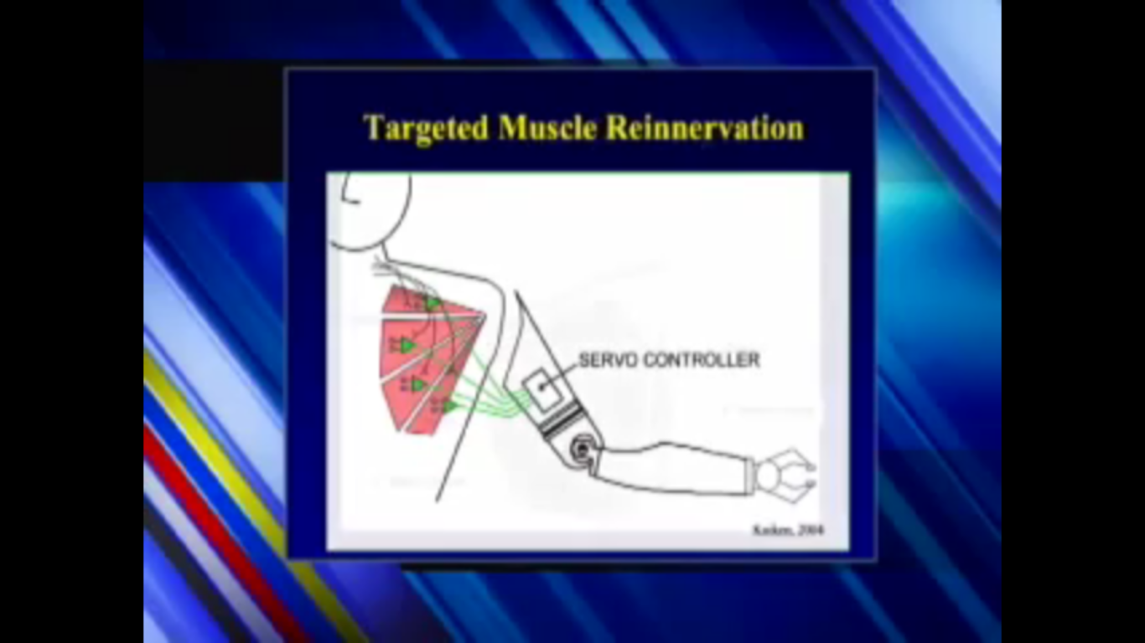

Targeted muscle reinnervation is a method by which a spare muscle (the target muscle) of an amputated patient is denervated (its original nerves cut and/or de-activated), then reinnervated with residual nerves of the amputated limb. The resultant (electromyogram) [EMG](http://en.wikipedia.org/wiki/Electromyography) signals of the targeted muscle now represent the motor commands to the missing limb, and are used to drive a motorized prosthetic device.

Targeted sensory reinnervation is a method by which skin near or over the targeted muscle is denervated, then reinnervated with afferent fibers of the remaining hand nerves.[[2]](http://en.wikipedia.org/wiki/Targeted_reinnervation#cite_note-KuikenEtAl2007-1) Therefore, when this piece of skin is touched, it provides the amputee with a sense of the missing arm or hand being touched.

Targeted reinnervation does not require any implants. Therefore, it does not have the issue of tissue foreign body response as chronic brain implant technology does. The targeted muscle acts as a natural amplifier for the neuronal signals produced by the transferred residual nerves. This is an advantage over technologies like EEG and fMRI that utilize weaker signals. With targeted reinnervation, multiple yet independent EMG signals can be produced, thus multiple functions of the [artificial limb](http://en.wikipedia.org/wiki/Artificial_limb) can be controlled simultaneously

<http://www.youtube.com/watch?v=T6R5bm6qx2E>

<http://en.wikipedia.org/wiki/Targeted_reinnervation>